MULTIMODE SCANNING PROBE MICROSCOPE, (SPM) (NT-MDT, NTEGRA)

Faculty-in-charge: Prof. P. Biji, PSGIAS
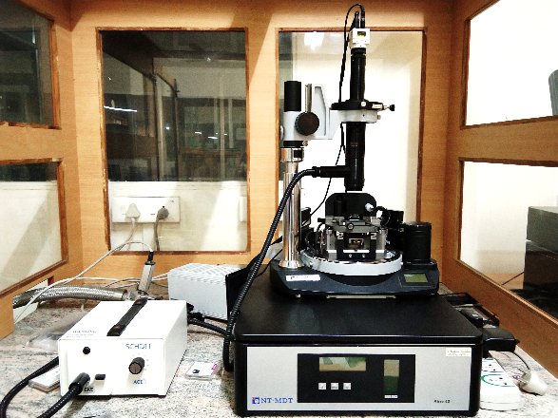
- AFM Imaging: Contact / Semi-contact mode
Special Techniques available:
- In Air and Vacuum: Scanning Tunneling Microscopy (STM), Lateral Force Microscopy (LFM), Phase Imaging, Force Modulation, Magnetic Force Microscopy (MFM), Adhesion force imaging, AFM Lithography, Spreading Resistance Imaging (SRI), Scanning Kelvin Probe Microscopy (SKM), Heating Stage Operations, Nanoscelerometry with AFM-Nanoindentation.
- In Liquid: Contact AFM/LFM/Adhesion Force Imaging/Force Modulation, Resonant Mode, Phase Imaging, AFM Lithography, Electrochemical AFM/STM Imaging
Researchers from internal (PSG)/external institutions are welcome to use this facility. Those who want to avail these facilities are requested to send the job requisition form (download from PSGIAS website) and advance payment (IMPS/NEFT) in favor of “PSG Institute of Advanced Studies” payable at Coimbatore to:
Dr. P. Biji,
Professor & Head
Department of Chemistry & Nanoscience and Technology
PSG Institute of Advanced Studies,
PB No: 1609, Peelamedu,
Coimbatore-641004.
E-mail: pbm@psgias.ac.in
Phone: +91-4224344000 (Extn: 4322)

Rules and Charges for using the facility:
- The testing/consultancy facilities at PSGIAS are extended to support research activities of external users on advance payment basis ONLY. Prior registration is essential to avail PSGIAS testing/consultancy facilities. We do not provide certification with results.
- User can do prior registration with submission of job requisition form and discussions for availing SPM facility can be done through Email to: pbm@psgias.ac.in.
- Appointment will be given as per queue and the slot will be informed through E-mail/Phone.
- Users should pay the charges in advance along with job requisition form. NEFT, Online transactions (Google Pay, PhonePe or Paytm) should be in the name of “PSG Institute of Advanced Studies” and payable at Coimbatore. Cash and DD will not be accepted. No refund of the payment or No Additional Discount will be made in any case.
- For a better analysis, basic details about the sample should be provided.
- Sample preparation should be done by the user.
- The samples should be sent through courier/post or in person along with payment details and results will be sent through E-mail.
- Please make sure to collect payment receipt after testing. The bill or invoice copy of the samples can be collected from technical staff either in-person or through mail, after completion of the testing.
Analysis charges:
(*All rates are for single run and exclusive of service tax. 18% GST will be applicable additionally)

Modes | Internal (PSG  Institutions (INR) | External Colleges  & Universities (INR) | Industry (INR)
Atomic Force Microscopy (AFM)  (Contact/Semi-contact mode) | 600 | 1600 | 3200
Lateral Force Microscopy (LFM) | 600 | 1800 | 3600
Spreading Resistance Imaging (SRI) | 600 | 1800 | 3600
Force Modulation mode | 600 | 1700 | 3400
Phase imaging | 600 | 1700 | 3400
Adhesion Force Imaging | 500 | 1400 | 2800
Kelvin Probe Microscopy | 700 | 2500 | 5000
Heating Stage operations | 700 | 2500 | 5000
Nanoindentation | 700 | 2500 | 5000
Liquid stage Operations | 700 | 2500 | 5000
In Vacuum condition | 700 | 3000 | 6000
Scanning Tunneling Microscopy | 700 | 2500 | 5000
Electrochemical AFM/STM | 1100 | 3000 | 6000
Lithography | 700 | 2500 | 5000

Account Details for payment (*DD is not accepted)

Beneficiary name : PSGIAS
Account Number : 1481412317
GST : 33AAATP2881NAZY
Bank Branch and address : Central Bank of India, Peelamedu, Coimbatore – 641004
IFSC : CBIN0280913

