Confocal Raman/AFM Microscopy (WITec alpha control 300 RA)

Faculty-in-charge: Prof. P. Biji, PSGIAS
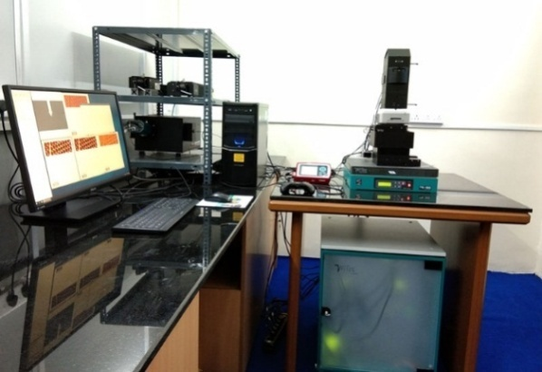
Confocal Raman Microscope with AFM imaging (WiTec alpha 300, Germany) existing at PSG Institute of Advanced Studies is an integrated system with high resolution nanoimaging capability can be mainly used for chemical analysis at sub-micrometer scale. The confocality of the optical design facilitates excellent depth resolution and makes the generation of 3D Raman images and depth profiles easily with a Raman Spectral range of 50 cm⁻¹ - 4000 cm⁻¹. Confocal micro-Raman spectroscope has features such as, Single-point spectra acquisition, Single-point depth profiling and 3D imaging and depth profiling. The advantage of an integrated system with a combination of ultra-high topographic and lateral resolution of AFM with Raman spectroscopy provides a more comprehensive understanding of the samples; not only the chemical information, but also structural and topographic information acquired at the same time and from the same sample area. The system is integrated with a motorized stage as well as high resolution piezo XYZ mapping Stage with AFM imaging capability. The instrument is equipped with 355 nm and 532 nm lasers as UV Excitation Laser source for PL analysis and VIS Excitation Laser source for Raman analysis respectively. Using optical pre-inspection by means of various illumination and detection techniques (e.g. bright field, dark field, polarization, fluorescence, etc.) the area of interest for the AFM/Raman imaging can be easily determined. The system is capable of measuring the Raman spectra of wide variety of samples including amorphous, crystalline, polymer or liquid/biological samples. Researchers from internal (PSG)/external institutions are welcome to use this facility. Those who want to avail these facilities are requested to send the job requisition form (download from PSGIAS website) and advance payment (IMPS/NEFT) in favor of “PSG Institute of Advanced Studies” payable at Coimbatore to:
Dr. P. Biji,
Professor & Head
Department of Chemistry & Nanoscience and Technology
PSG Institute of Advanced Studies,
PB No: 1609, Peelamedu,
Coimbatore-641004.
E-mail: pbm@psgias.ac.in
Phone: +91-4224344000 (Extn: 4322)

Rules and Charges for using the facility:
- The testing/consultancy facilities at PSGIAS are extended to support research activities of external users on advance payment basis ONLY. Prior registration is essential to avail PSGIAS testing/consultancy facilities. We do not provide certification with results.
- User can do prior registration with submission of job requisition form and discussions for availing Confocal Raman Microscope facility can be done through Email to: pbm@psgias.ac.in.
- Appointment will be given as per queue and the slot will be informed through E-mail/Phone.
- Users should pay the charges in advance along with job requisition form. NEFT, Online transactions (Google Pay, PhonePe or Paytm) should be in the name of “PSG Institute of Advanced Studies” and payable at Coimbatore. Cash and DD will not be accepted. No refund of the payment or No Additional Discount will be made in any case.
- For a better analysis, basic details about the sample should be provided.
- Sample preparation should be done by the user.
- The samples should be sent through courier/post or in person along with payment details and results will be sent through E-mail.
- Please make sure to collect payment receipt after testing. The bill or invoice copy of the samples can be collected from technical staff either in-person or through mail, after completion of the testing.
Analysis charges:
(*All rates are for single run and exclusive of service tax. 18% GST will be applicable additionally)

Modes | Internal (PSG  Institutions (INR) | External Colleges/ Universities (INR) | Industry  (INR)
Raman spectra | 200 | 400 | 600
Raman spectra with imaging | 600 | 1200 | 3000
Raman with AFM imaging | 1100 | 3250 | 6000

Account Details for payment (*DD is not accepted)

Beneficiary name : PSGIAS
Account Number : 1481412317
GST : 33AAATP2881NAZY
Bank Branch and address : Central Bank of India, Peelamedu, Coimbatore – 641004
IFSC : CBIN0280913

