Brunauer Emmett Teller (BET) Analysis
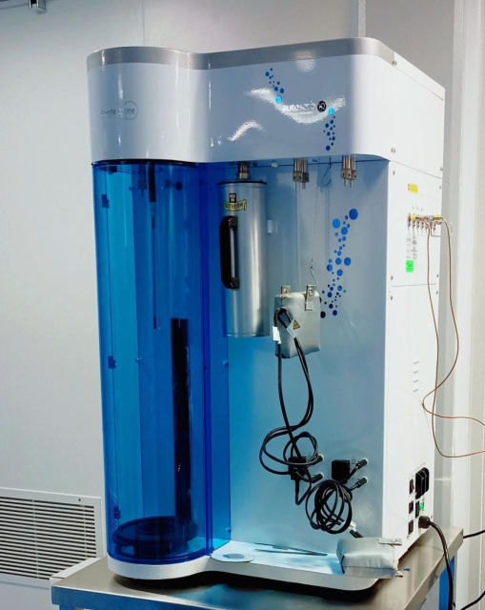
Faculty-in-charge: Prof. P. Biji, PSGIAS
Brunauer–Emmett–Teller (BET) Autosorb IQ-MP series (Single station), Quantachrome Instruments, Anton Paar Pvt. aims to analyze the physical adsorption of gas molecules on a solid surface and serves as the basis for an important analysis technique for the measurement of the specific surface area of materials. The BET theory applies to systems of multilayer adsorption and usually utilizes probing gases that do not chemically react with material surfaces as adsorbates to quantify specific surface area. Nitrogen is the most commonly employed gaseous adsorbate used for surface probing by BET methods. For this reason, standard BET analysis is most often conducted at the boiling temperature of N₂ (77 K). Specific surface area is a scale-dependent property, with no single true value of specific surface area definable, and thus quantities of the specific surface area determined through BET theory may depend on the adsorbate molecule utilized and its adsorption cross section. This instrument can be extensively utilized for the measurement of specific surface area (single and multi-point B.E.T., Langmuir, t-plot, DR), pore size (BJH, DH, NLDFT,) with their corresponding surface area values can be analyzed. Researchers from internal (PSG)/external institutions are welcome to use this facility. Those who want to avail these facilities are requested to send the job requisition form (download from PSGIAS website) and advance payment (IMPS/NEFT) in favor of “PSG Institute of Advanced Studies” payable at Coimbatore to:
Dr. P. Biji,
Professor & Head
Department of Chemistry & Nanoscience and Technology
PSG Institute of Advanced Studies,
PB No: 1609, Peelamedu,
Coimbatore-641004.
E-mail: pbm@psgias.ac.in
Phone: +91-4224344000 (Extn: 4322)

Rules and Charges for using BET facility at PSG IAS

- The testing/consultancy facilities at PSGIAS are extended to support research activities of external users on advance payment basis ONLY. Prior registration is essential to avail PSGIAS testing/consultancy facilities. We do not provide certification with results.
- User can do prior registration with submission of job requisition form and discussions for availing BET facility can be done through Email to: pbm@psgias.ac.in
- Appointment will be given as per queue and the slot will be informed through E-mail/Phone.
- For a better analysis, basic details about the sample should be provided.
- Before giving the sample for BET analysis, the sample may be characterized by TGA.
- Users should pay the charges in advance along with job requisition form. NEFT, Online transactions (Google Pay, PhonePe or Paytm) should be in the name of “PSG Institute of Advanced Studies” and payable at Coimbatore. Cash and DD will not be accepted. No refund of the payment or No Additional Discount will be made in any case.
- The samples should be sent through courier/post or in person along with payment details and results will be sent through E-mail.
- Please make sure to collect payment receipt after testing. The bill or invoice copy of the samples can be collected from technical staff either in-person or through mail, after completion of the testing.
Analysis charges

(*All rates are for single run and exclusive of service tax. 18% GST will be applicable additionally)
Facility | PSGIAS | Internal  PSG INSTITUTIONS (INR) | External colleges and Universities (INR) | Industry  (INR)
BET | 500 | 1,600 | 3,200 | 6,500
*Charge includes specimen loading and degassing along with the analysis.
Account Details for payment (*DD is not accepted)

Beneficiary name : PSGIAS
Account Number : 1481412317
GST : 33AAATP2881NAZY
Bank Branch and address : Central Bank of India, Peelamedu, Coimbatore – 641004
IFSC : CBIN0280913

