X-ray Diffractometer (XRD) Facility
Empyrean, Malvern Panalytical
The 3rd generation Empyrean, Malvern Panalytical multipurpose diffractometer with MultiCore Optics is capable of a large variety of measurements from powders to thin films, from nanomaterials to solid objects - on a single instrument, without much manual intervention.
X-Ray sources: Cu Kα (λ = 1.54 Å) (default) and Mo Kα (λ = 0.71 Å) (on request)
Techniques:
1. Rapid powder X-ray diffraction (PXRD): Powder XRD done at standard angular resolutions is rapid and gives precise data with high intensity peaks. Very high angular resolution scans are also possible. Sample type: powder, metallic, thin films, liquid and polymer samples
2. Grazing incidence X-ray diffraction (GIXRD) for thin films: Grazing incidence x-ray diffraction is used to find the thickness of thin crystalline films (20-200nm depending on mean atomic number) on polished, flat surfaces. It is possible to deal with multiple films to a limited extent
3. 2D scan to view the diffraction patterns in two dimensional texture analysis using pole figures for metallic samples

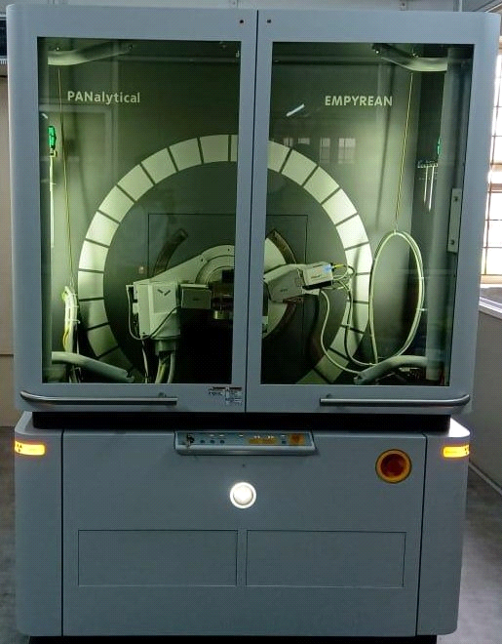

Software packages:
Data collector - to collect the XRD spectrum
Data viewer - to visualize the XRD spectrum
X’Pert Highscoreplus – processing of XRD spectrum, Profile fitting, Williamson Hall plots and
Rietveld refinements
X’pert texture – for texture analysis using pole diagrams.
XRD 2D scan – to visualize the patterns in 2D.
PDF-2 – Crystallographic database

Charges for XRD analysis:
 | Analysis charges (Rs)*
Analysis mode | Internal (PSG Institutions) | External (Educational and research Institutions) | Industry
Powder XRD (PXRD) | 200 | 300 | 500
Grazing Incidence XRD (GIXRD) | 300 | 500 | 1000
Peak fitting/others, per sample | 25 | 50 | 100
*GST@18% will be added extra

